**Air University**

**Mid Semester Lab Examination: Fall 2021**

**Computer networking .**

# Question 01: For the following IP Addresses, Identify the following:

**1) Class (A, B, C, D, E)**

**2) Network-Host Division (Example: N.N.N.H)**

**3) Subnet Mask (Example: 255.0.0.0)**

Sr.No IP Class Network.div Subnet Mask

|  |  |  |  |  |
| --- | --- | --- | --- | --- |
| 1 | **139.34.23.1** | **B** | N.N.H.H | **255.255.0.0** |
| 2 | **219.80.60.110** | **C** | N.N.N.H | **255.255.255.0** |
| 3 | **24.254.254.254** | **A** | N.H.H.H | **255.0.0.0** |
| 4 | **10.80.10.1** | **A** | N.H.H.H | **255.0.0.0** |
| 5 | **100.1.1.1** | **A** | N.H.H.H | **255.0.0.0** |
| 6 | **122.11.12.22** | **A** | N.H.H.H | **255.0.0.0** |
| 7 | **166.77.88.80** | **B** | N.N.H.H | **255.255.0.0** |
| 8 | **34.200.234.12** | **A** | N.H.H.H | **255.0.0.0** |
| 9 | **193.254.254.254** | **C** | N.N.N.H | **255.255.255.0** |
| 10 | **200.200.200.200** | **C** | N.N.N.H | **255.255.255.0** |

# Question 02: Complete the following network in Packet Tracer:

**Network-1:**

1. **Add a PC**

Rol.no 201001

**Network-2:**

1. **Add a PC**

**Add a Router (2911):**

**PING:**

# Question 03: Implement Static Routing in the Network

**Network-1:**

1. **Add first PC**

1. **Add second PC**

**Network-2:**

1. **Add first PC**

1. **Add second PC**

STATIC

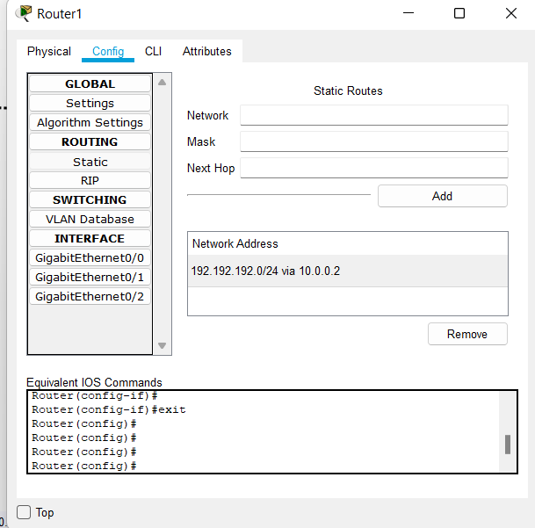  
  
ping :

